To Special issue of Forests. <https://www.mdpi.com/journal/forests/special_issues/Assessing_Ecosystem>

**Real-time monitoring of ecosystem services provided by green infrastructure on a tree level: possibilities and challenges.**

**Abstract.**

Sustainable urban development is one of the priorities of mankind for the near future, and it implies the rational use of urban nature capital and the maximization of urban ecosystem services. Urban green spaces play an essential role in the sustainable functioning of urban ecosystems and provide the most important regulating and cultural ecosystem services. Meanwhile cities are entering a new age of widespread data collection, processing, and utilization in urban decision-making, as well as citizen involvement and empowerment in city planning. It is necessary to expand the uses of digital and computing technologies to green infrastructure management, as it is a crucial component for human well-being under the rapid urbanization.

The Bolotnaya square was chosen as a study site that represents urban green infrastructure under the high influence of urban heat island and high level of anthropogenic load. It is a small green area (370m length and 120m width) situated on the island Balchug in the center of Moscow, 600m to the south from the Kremlin. For real-time monitoring nineteen TreeTalkers that provide data on physiological conditions of a single tree were installed to describe different species in their local conditions (neighborhood tree density, edge effect, etc.). All measurements were conducted from 1 July to 31 November with 1,5 hour time resolution. We used R programming language for descriptive statistics and data processing. To move from parameters of trees functioning to provided ecosystem services we established several indicators related to climate, air and water regulation.

Our results show that the average tree in Moscow center reduced extreme heat on 2.5 C degree and cooled down the area by consuming energy on 4000KWh, transpires 5 m3 of water, deposits 15 kg of Carbon and absorbs 300 g of PM10. But the real values for different species vary (up to five-ten times) under the influence of local conditions and also depends substantially on seasonal and weather changes. Thus, it is crucial to use real-time monitoring data to understand deeper the processes in urban forests. There is a new opportunity of applying IoT technology not only to measure the functioning flows, but to establish a smart urban green infrastructure management based on ecosystem services indicators.

**Key words**: Ecosystem services, Ecological engineering, Green infrastructure, Real-time monitoring, Smart monitoring, Smart cities, Sustainability, TreeTalker, Trees, Urban forests.

**1. Introduction**

*1.1. Urban growth and how people depend on ecosystem services*

Urbanization is increasing on a global scale, and today more than half of the world's population lives in cities (Dye 2008) and more than two thirds are expected to live in cities by 2050 (UN, United Nations, 2010). Concentration of population in cities plays a significant role in fostering economic development and encouraging innovation (UN-Habitat, 2012) due to economies of scale (Bettencourt et al. 2007). In addition this process may also have negative effects on many aspects of human well-being, including increasing crime rates (Bettencourt et al. 2007) and growing health risks (Frumkin 2003; Lederbogen et al. 2011). Moreover, it was shown that urban areas significantly contribute to climate change and global carbon emissions, ecosystem degradation and biodiversity loss on a global scale (Grimm et al. 2008; Seto et al. 2012). It is well-known that people living in urban areas depend on natural ecosystems not only within the city limits, but also beyond the urban area (Bolund and Hunhammar 1999) thus demands on natural capital and ecosystems services keep increasing steadily (Guo et al. 2010; Krausmann et al. 2018).

*1.2. Ecosystem services concept as a key to sustainable urban planning.*

The ecosystem services (ES) concept, which emerged from ecological economics in 1990s, allows to understand and explain human-environmental interactions complexity if we want to balance interlinked sustainable goals in landscape planning (Wilkinson et al. 2013; Vihervaara et al. 2019). Scientists argue that ES concept could be used as a new Esperanto (Spyra et al. 2019) because its communicative power in participatory planning processes (Opdam et al. 2015; Haaren et al. 2019). But such comprehensive planning approach requires planners to assess and value nature’s contributions to the human well-being (UNEP 2010; Gómez-Baggethun and Barton 2013), especially in a cities as a coupled human-environment systems (Wu 2013). The concept of ES and its application to urban environments were addressed by major initiatives like the Millennium Ecosystem Assessment and The Economics of Ecosystems and Biodiversity, and have gained increasing attention in literature (Bolund and Hunhammar 1999; Haase et al. 2014; Kremer et al. 2016) and in a policy debate on green infrastructure (Horizone2020, ESMERALDA). However, ES concept might be too complex and sometimes does not meet the real world and requirements for planning applications, and even might be misinterpreted in practice (Luederitz et al. 2015; La Rosa et al. 2016; Czúcz et al. 2018). It is common situation when decision-makers pay attention to visible and directly usable ES, which are mainly provisional and cultural ES and underestimate the value of regulating and habitat ES (Wissen Hayek et al. 2016; Mascarenhas et al. 2016; van Oudenhoven et al. 2018).

*1.3. Regulating ES from GI and ways to assess it.*

Urban green infrastructure (UGI) play an essential role in the sustainable functioning of urban ecosystems and provide the most important regulating and habitat ecosystem services such as carbon sequestration, microclimate formation, pollution and dust reduction in atmospheric air, water balance control, wildlife habitat, wind and noise reduction, etc. (Gómez-Baggethun and Barton 2013; Lovell and Taylor 2013; Andersson et al. 2014). The magnitude of the ES provided depend on the characteristics of UGI, such as vegetation type, age, structure and management practices, which is important compare to natural ecosystems. This may cause a trade-off between which service is maximized (Bodnaruk et al. 2017), or between ecosystem services and disservices (Speak et al. 2018; Teixeira et al. 2019) and could be a reason for cost-benefit analysis (Song et al. 2018; von Döhren and Haase 2019). There are several studies that assess ES in different types of UGI (Nowak et al. 2006; Lovell and Taylor 2013; Blanusa et al. 2019), in areas with the same typology but different types of management (Lilly et al. 2015; Schwilch et al. 2018) or in different types of vegetation within the same area (Mexia et al. 2018). Several types of models such as Artificial Intelligence for Ecosystem Services (ARIES) and the Integrated Valuation of Ecosystem Services and Tradeoffs (InVEST) identifies ES via proxies, typically land-use/cover, based on expert knowledge and causal relationships. Urban ES assessing presents a special case due to the high, fine-resolution spatial heterogeneity of these landscapes that could lead to high mapping error (Zhao and Sander 2018). That is why to better understand the ES provided by UGI researchers conducted direct measurements of different processes (Nowak and Crane 2002; Nowak et al. 2006, 2018), and its modeling (Lin et al. 2019; Rötzer et al. 2019) on a tree-level, which yielded in wide spreading use of software and tools, such as i-Tree model (<http://www.itreetools.org>).

*1.4. Process-Indicator-Value. How to find a clear and useful indicators of ES.*

Our understanding of the relationships between functional flows in ecosystems and services they provide is still very incomplete (Van Reeth 2013; Drobnik et al. 2018). To overcome this high complexity in human-environmental systems scientists use ecological indicators that generally are variables that provide aggregated information on certain phenomena (Müller and Burkhard 2012). For the ES assessment the importance of developing appropriate indicators has been recognized (Burkhard et al. 2018; van Oudenhoven et al. 2018) and many ES indicators have been developed, applied, tested and reviewed (Gómez-Baggethun and Barton 2013; La Rosa et al. 2016; Wissen Hayek et al. 2016). ES indicators need to be relevant to specific purpose (e.g. to reflect difference in land management - van Oudenhoven et al. 2012) or component (e.g. soils - Andrea et al. 2018; Drobnik et al. 2018) or spatial-temporal scale (Norton et al. 2016; Aalders and Stanik 2019) to avoid uncertainties from that side, but at the same time ES indicators should inform decision making (Willcock et al. 2016; Czúcz et al. 2018; van Oudenhoven et al. 2018). It’s completely clear for decision-makers that “you cannot manage what you do not measure”, thus these indicators should be linked to measurable policy targets and should help to monitor policy progress. And from another side we see a growing interest from citizens to the widespread measurements of the environmental conditions they are living in (Schröter et al. 2017; Njue et al. 2019), so it is also necessary to create clearly understandable indicators for involving people. We should also take into account fast development of cutting-edge technologies of observation, modeling, computing and even acting in a new Industry 4.0 world (Nitoslawski et al. 2019).

*1.5. Smart Urban Forest and trends in technologies.*

The widespread integration into the urban environment of Information and Communication Technologies (ICTs) and Internet of Things (IoT) tools makes our cities “smart” (Albino et al. 2015). Smart technologies are already being applied in environmental management. The species and structure of individual trees was mapped and assessed with remote sensing, aided by machine learning (Alonzo et al. 2014). Forest regeneration was assisted by drones or unmanned aerial vehicles (UAVs) through surveying, fertilizer spraying, and precision aerial seeding (Elliott 2016). Wireless sensor networks have been deployed in greenhouse settings to measure and regulate environmental parameters (Mesas-Carrascosa et al. 2015). Acoustic sensors were used to assess the urban noise pollution (Farina et al. 2014; Mydlarz et al. 2019). The huge data collected through these technologies provide more insight into the UGI and can be used in analysis, modeling, and prediction (Kitchin 2014). Traditional monitoring methods do not allow assessing the state of UGI with the spatial-temporal resolution needed for the diagnosis of stressful situations and for decision-making on the management and development of an urban environment. Such new smart digital technologies can be used as tools to improve the human well-being through balancing the ES provided by UGI. The use of wireless network sensors and data loggers can provide information about environmental parameters at a local scale and its visualization in real time (Kitchin 2014; Nitoslawski et al. 2019).

So, the aim of this work is to show the possibilities and discuss the challenges of real-time tree-level monitoring of ecosystem services in urban conditions. We decided to:

* 1) test the real-time monitoring technology by measuring trees functioning parameters in different conditions
* 2) justify the indicators that can be useful to interpret measurements in terms of ecosystem services
* 3) analyze local factors influencing ecosystem services

**2. Materials and Methods.**

2.1. Study site and installations

Bolotnaya square is a small green area (370m length and 120m width) situated on the island Balchug in the center of Moscow (Figure1), 600m to the south from the Kremlin. Now it’s became well-known through meetings of political opposition. This site located only 700m to the west from Balchug meteorological station that provided data each 3 hours. Study area represents urban green infrastructure under the high influence of urban heat island and high level of anthropogenic load. The main works on its improvement (tree planting) were completed by 1948. So, it was possible to analyze the influence of local biotic factors (species, height, local neighborhood standing conditions, age).

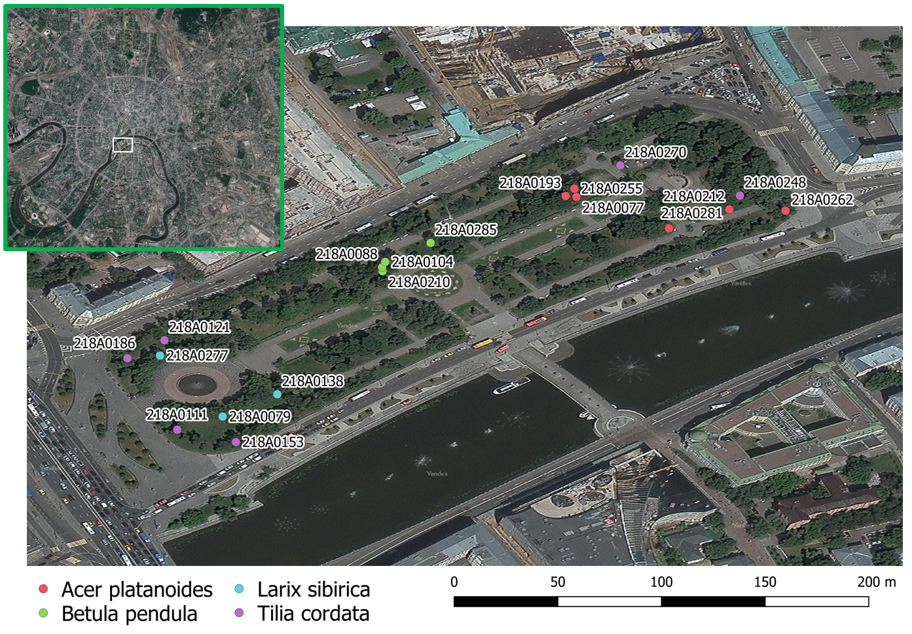

Figure1. Study area.

Nineteen TreeTalker+ (TT+) devices (Valentini et al. 2019) were installed on the trees: 6 on *Acer platanoides* (average DBH 38.7 cm), 4 on *Betula pendula* (average DBH 21.8 cm), 3 on *Larix sibirica* (average DBH 32.1 cm) and 6 on *Tillia cordata* (average DBH 34.1 cm). During the first observation all trees were characterized by height, diameter, age group, VTA score (from 1 which is the best to 7) and standing type (table 1).

Table 1. Basic characteristics of the trees.

|  |  |  |  |  |  |  |
| --- | --- | --- | --- | --- | --- | --- |
| **Tree ID** | **Species** | **Height, m** | **Diameter, cm** | **Age** | **Standing type** | **VTA score** |
| 218A0281 | *Acer platanoides* | 14 | 45.83 | 50-60 | Inner group | 4 |
| 218A0077 | *Acer platanoides* | 20 | 35.65 | 50-60 | Inner group | 2 |
| 218A0262 | *Acer platanoides* | 14 | 34.69 | 50-60 | Edge group | 1 |
| 218A0255 | *Acer platanoides* | 21 | 34.37 | 50-60 | Inner group | 2 |
| 218A0212 | *Acer platanoides* | 15 | 33.74 | 50-60 | Inner group | 3 |
| 218A0285 | *Betula pendula* | 11 | 23.87 | 50-60 | Inner single | 1 |
| 218A0104 | *Betula pendula* | 11 | 21.65 | 30-40 | Inner group | 1 |
| 218A0210 | *Betula pendula* | 11 | 21.00 | 30-40 | Inner group | 1 |
| 218A0138 | *Larix sibirica* | 19 | 40.74 | 80-100 | Inner group | 2 |
| 218A0079 | *Larix sibirica* | 25 | 32.14 | 80-100 | Inner group | 3 |
| 218A0277 | *Larix sibirica* | 24 | 26.10 | 80-100 | Inner group | 2 |
| 218A0186 | *Tilia cordata* | 17 | 40.42 | 50-60 | Edge group | 3 |
| 218A0121 | *Tilia cordata* | 16 | 37.87 | 50-60 | Inner group | 1 |
| 218A0153 | *Tilia cordata* | 14 | 35.33 | 40-50 | Edge group | 2 |
| 218A0111 | *Tilia cordata* | 12 | 28.01 | 40-50 | Edge group | 3 |
| 218A0270 | *Tilia cordata* | 11 | 25.14 | 30-40 | Inner single | 3 |

To obtain data on surrounding environmental conditions one reference TT+ (TT-R) was mounted on a dead tree without canopy similar to mast due to no permissions to install on city infrastructure like lights. The devices were placed at a height of 3 m from the ground on the north side of the trunk and the batteries - on the south side, which reduces the risk of damage or theft of devices. All measurements were conducted from 01 July till 31 November with 1,5 hour temporal resolution. Measured parameters presented with their indexes and units in table 2.

Table 2. Measured parameters.

|  |  |  |  |
| --- | --- | --- | --- |
| **Parameter** | **Index** | **Units** | **Device** |
| Air temperature | ATr – for TT-R  and ATt – for TT | C degrees | TT and TT-R |
| Air humidity | AHr – for TT-R  and AHt – for TT | % | TT and TT-R |
| Sap flow | Flux | l | TT |
| Distance to trunk | Dt | mm | TT |
| Trunk temperature | nt1 | C degrees | TT |
| Trunk humidity | W | % | TT |
| Canopy spectral characteristics according to spectral bands | Bir – for TT-R  and Bit – for TT, where i wavelengths of band center | Digital numbers | TT and TT-R |

2.2. Justification of the ES Indicators.

As we wanted to provide clearly understandable Ecosystem Services Indicators, we assumed relations between measured parameters and indicators based on existed literature (Gómez-Baggethun and Barton 2013; Andersson-Sköld et al. 2018) and summed up described relations with possible calculations and key references in table 3. Direct measurements (like air temperature or relative humidity) gave us an opportunity to calculate ESI without any additional assumptions. But all the ESI that is labeled as “indirect” required us to introduce some adjustment factors or assumptions. Several ESI could be calculated easily via using LAI, but not for all of them we had enough information (e.g. gas concentrations in the air or noise level) and possibilities to verify the results, so we decided to show only LAI dynamics instead of manipulating with unproved data. As an example of usefulness of LAI we focused on particulate adsorption.

Table 3. Indicators of ES, provided by urban trees

|  |  |  |  |  |  |  |
| --- | --- | --- | --- | --- | --- | --- |
| **ES group** | **Type of ES** | **Indicator** | **Sensor** | **Type of equation** | **Units** | **Key references** |
| Global Climate regulation | Carbon sequestration | Tree stamp growth rate | IR sensor | Indirect | kg C | (Ruimy et al. 1994; Nowak and Crane 2002; Gratani and Varone 2006) |
| Local Climate regulation | Cooling Effect | Temperature reduction | Thermo-hygrometer | Direct | C degrees | Land surface temperature (Marando et al. 2019; Tonyaloğlu 2020) and climate comfort level (Krayenhoff et al. 2020; Morakinyo et al. 2020) |
| Energy consumption | Thermo-hygrometer | Indirect | KWh | Exergy (Puzachenko et al. 2013; Puzachenko et al. 2016), Energy balance (Krayenhoff et al. 2020) |
| Humidity reduction | Humidity reduction | Thermo-hygrometer | Direct | % | Humidity control (Moghbel and Erfanian Salim 2017) |
| Wind reduction | Wind velocity reduction | Spectrometer | Proxy  ~LAI | % | Wind comfort level (Lee et al. 2010; Hefny Salim et al. 2015; Kang et al. 2020; Zeng et al. 2020) |
| Water regulation | Run-off mitigation | Evapotranspiration | Thermo-hygrometer probes | Indirect | m3/hr | (Cascone et al. 2019; Chen et al. 2019) |
| Rain buffer | Spectrometer | Proxy  ~LAI | % | Rainfall buffer (Fernanda V. et al., ,2019) |
| Air quality regulation | Particulate adsorption | PM removal | Spectrometer | Indirect | g | (Hirabayashi et al. 2012; Nowak et al. 2013; Nowak et al. 2018; Buccolieri et al. 2019) |
| Gas regulation | Gas removal | Spectrometer | Indirect ~LAI | g |
| Human health regulation | Acoustic environment regulation | Noise reduction | Spectrometer | Proxy  ~LAI | % | (Martens and Michelsen 1981; Yang et al. 2013; Van Renterghem 2014) |

*2.2.1. Carbon sequestration*

Carbon sequestration assessment was based on IPCC 2006 approach utilizing biomass expansion factor (BEF)

ΔC = [ΔV * BCEF] * (1 + R) * CF

where BCEF = BEF * D and R(root to shot ratio) was taken from literature according to species and age of the tree (Schepaschenko et al. 2018), CF was taken as 0.5. Trunk volume was calculated assuming it conic form, with height measured directly in field and trunk diameter expansion measured real time with TreeTalkers IR distance sensor.

*2.2.2. Air temperature and humidity reduction*

Direct measurements of temperature and humidity reduction based on the difference between data form thermo-hygrometers of TT and TT-R.

*2.2.3. Run-off mitigation via evapotranspiration*

Transpiration via Sap Flow (cumulative or hour by hour)

*2.2.4. Energy consumption*

The energy absorbed by tree is the result of this equation: Rn= L + H + G, where L is energy spent in transpiration (the latent heat for vaporization of water = 2264.705 KJ/KG), H is the sensible heat, the heat transferred or absorbed by the tree by convective heat transfer, G is the heat transferred to the soil by absorption on the energy which penetrate the canopy.

Sensible heat was calculated according to next equation:

(1)

Where cp – specific heat of air (1.006 kJ/kg C), ρ – air density (1.202 kg/m3), r – aerodynamic resistance, *Δ*T – temperature difference between canopy leaves and air. Canopy temperature was not measured directly, and we assumed that temperature difference between canopy leaves and trunk are negligible in terms of this investigation. Trunk temperature are repeatedly measured as part of measuring sap flux density with heat dissipation probes. Aerodynamic resistance was calculated according to Tom’s model:

(2)

Where U = wind velocity at height z which was equal mean canopy height h=20m, z0= 0.15h, d=0.65h, k=von Karman constant (0.41).

Wind speed data was obtained from closest public weather station(300m) and recalculated for height 20m (height of the tree stand and main buildings) utilizing log law and taking roughness length = 0.6 . Gaps in weather data were linearly interpolated.

*2.2.5. LAI*

According to Monsi and Saeki (1953) canopy as porous media can be a subject of Beers law. To measure the sun light transmittance through the vegetation canopy and then calculate LAI photosynthetically active radiation was measured above (with TTR) and below canopy (with TT+).

(3)

Since light transmittance is blocked not only by leaves but also by woody parts of the plant, resulting values should be called plant area index(PAI) which consists of wood area index(WAI) and leaf area index(LAI). Assuming that WAI constant throughout vegetation period and LAI = 0 after defoliation (second part of October and November), WAI for each tree was calculated as mean PAI of November*.* Light extinction coefficient k was calculated per each species utilizing direct LAI measurement with litter traps

*2.2.6. Particulate adsorption*

Dry deposition of solid particles on canopy was calculated according to i-Tree Eco Dry Deposition Model (Hirabayashi et al., 2011):

Pads=Vd*C

Where C – PM10 concentration (g m-3) , Vd – velocity of deposition (m s-1), LAIPM10  – leaf area index for pollutant deposition (m2m-2) and VdPM10max,VdPM10avg,VdPM10min  – maximum, average and minimum deposition velocity for PM10 – 0.0064 ms-1, 0.0025 ms-1, 0.01 ms-1(Lovett 1994), respectively. Pollutant concentration was obtained from nearby open access pm10 sensors via Sensor.Community web portal.

2.3. Data processing.

Data collection with TreeTalker+ devices is organized according to next scheme. All types of devices(TT+ and TTR) made measurement every 90 minutes, stored data in internal memory, then according to predefined time window transmitted data to TT-cloud device via Low Power Wide Area Network (LoRaWan) wireless networking protocol. TT-cloud device is a gateway device in TreeTalkers devices ecosystem, which purpose is to collect data from all TT devices on site, store it and then transmit it to online database via WiFi or wireless mobile networks.

All remote data was collected and processed with R computing language (R Core Team, 2020). Field data was organized in a table and added to computation on early stages of processing. All measured parameters weekly data was three sigma filtered. Filtered data was linearly interpolated. Data from TT devices didn’t have gaps more than three days(battery malfunction), big gaps were filled with data from trees with closest parameters(species, trunk diameter, height, canopy size, position on site).

**3. Results.**

Basically, we assumed two types of results – hour by hour changes and sum for the total period – would be more interesting and informative to present.

3.1. Carbon sequestration.

All the dynamics show biomass grow to the end of September (around 260 day of a year) due to the warm autumn (Figure2). Betula’s grow stoped two weeks later than others, but variety was much less than others, possibly because they are the youngest trees among all. Acer #218A0281 had different dynamics with a rapid grow in the begginnig of the investigated period and he stoped grownig month and a half earlier than others that can be explaind with it’s lowest VTA score.

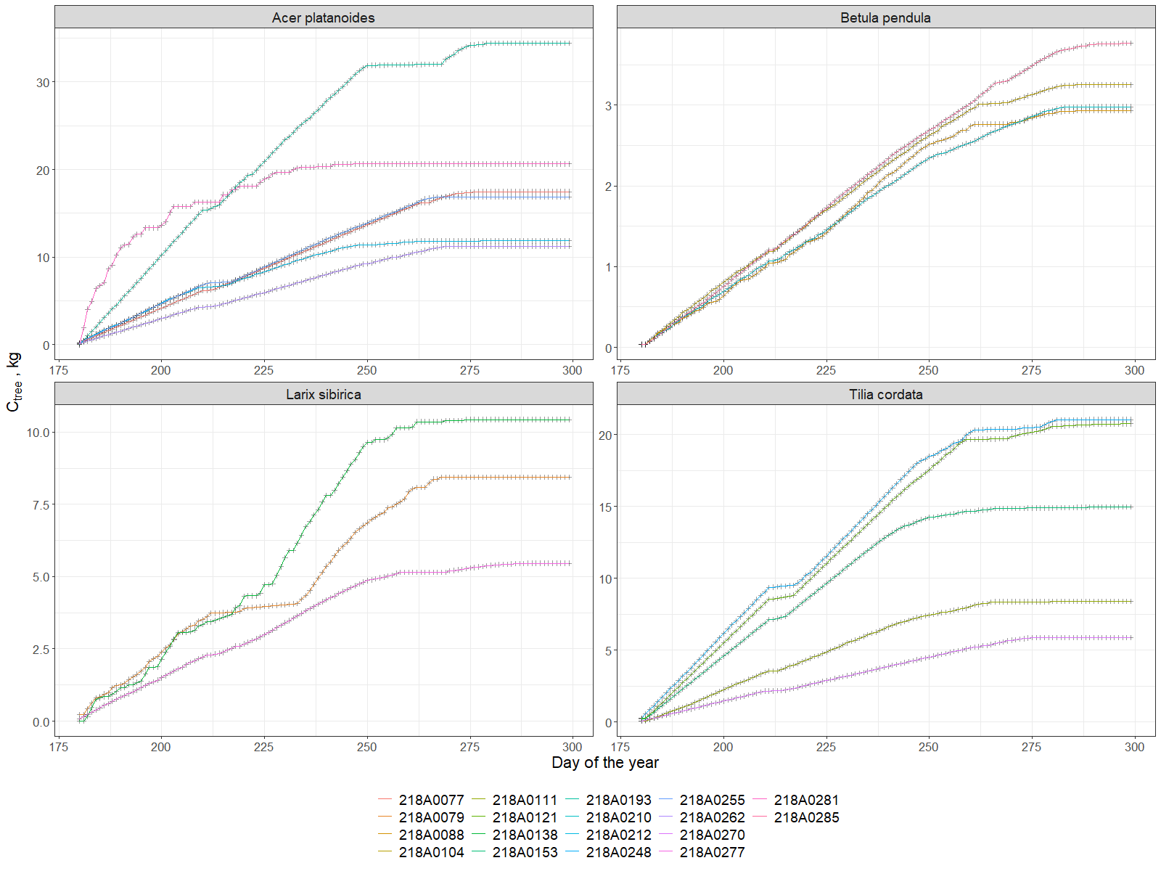

Figure2. Cumulative grow of Carbon stored for each of the tree.

In total the average accumalated Carbon (during half of the vegetational season) in the biomass of Acers was around 15 kg C. Larix accumalated about 7,5 kgC in average, and the lowest level was shown by Betula – 3kgC. The most diverse was Tillia – from 5 to almost 25 kgC that was related to the age and diameter. So, it is clear that diameter of the tree influence greatly the grow ratio and carbon sequestration as well.

* 1. Air Temperature and Humidity reduction.

For the global climate control it is more important to have summative storage of Carbon neither daily dinamics. But for the local climate control the most important thing from ecosystem service perspective is the mitigating extreme temperatures and providing comfort urban microclimate. That is why we decided to show the average of differences between maximum and minimum temperatures during the day without night outside and under the canopy (Figure3). While temperature amplitudes outside of the canopy (the black line) reached maximum ten degrees in August, under the canopy this amplitude was three degrees less. All the species showed similar dynamics through the investigated period, but under the larch canopies it was hotter, which is most likely due to the height of the crown, which is slightly higher than of others. And also in the late autumn after the defoliation and due to the decrease of the air temperature this mitigating heat effect was not observed.

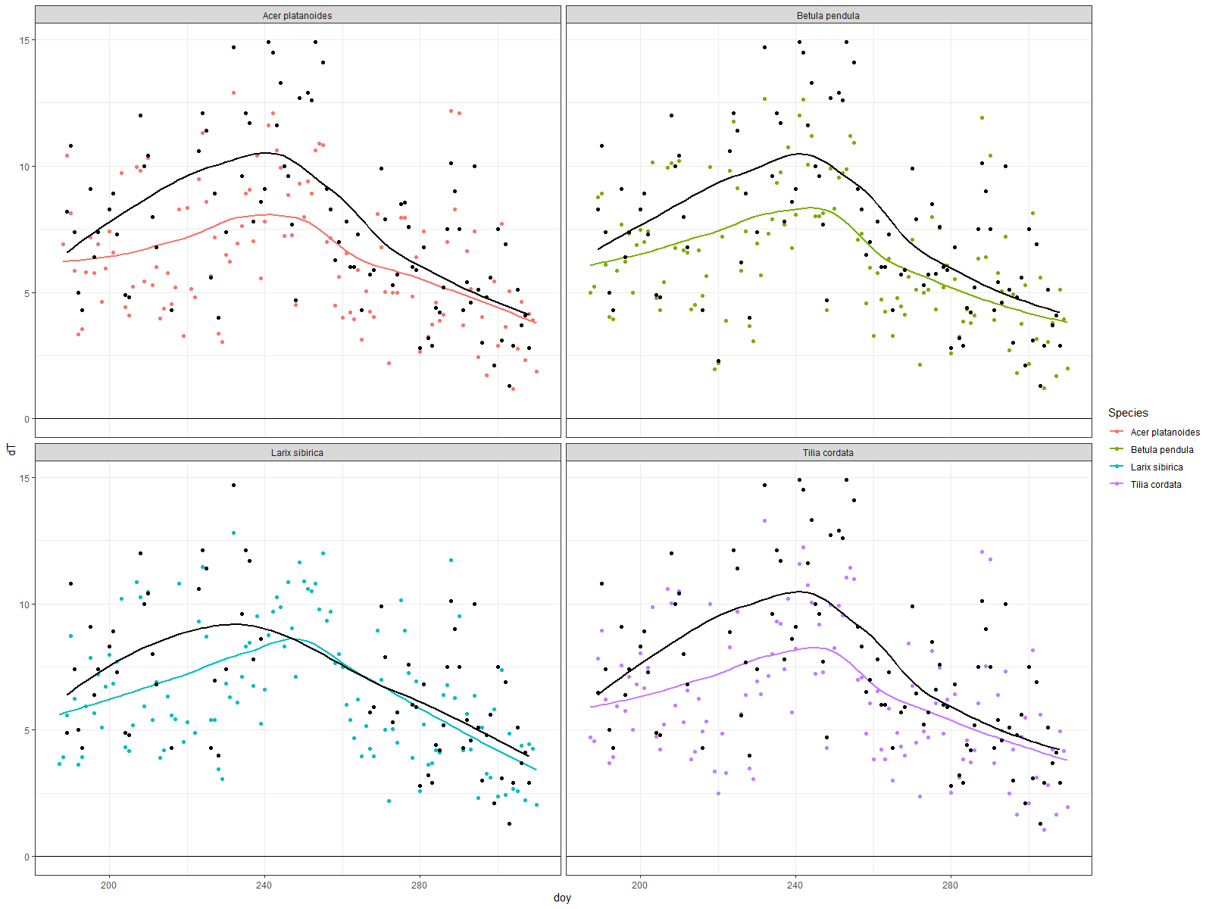

Figure3.

Our results (annex 1) show that temperature under the canopies was lower (with average reduction on two-three degrees) during day time, while during the night the temperature under the canopy was higher (but not more than one degree) than surroundings. There were no significant differences between this dynamics shown by species. But if we look at the average monthly differences – there are noticeable levels of the temperature reduction by the different species. During July the amplitude of dT associated with Betula was lower than Acer, while Larix and Tillia show the same results in a middle. In august the “leadership” in this indicator was taken by Larix. It’s very interesting, that during night time in September Larix was dissipating heat much higher than others – dT was around 1,5 C degrees. And in October there was a vice versa situation when temperature under the canopies during day time was higher than outside of the canopy, and lower during the nights. This once again confirmed the thesis that temporal dynamics are very important for interpretation, both daily and seasonal.

The average differences between the air relative humidity under and outside of the canopy were not more than 20% (annex 2). In a day time trees made air more humid, while during nights they reduced humidity. There were no seasonal changes through months, even no significant difference between species. We can only see the sinusoid line with delay in time as a result of functioning process of the transpiration.

* 1. Evapotranspiration

As it is well known that transpiration daily looks like sinusoid we decided to show here the cumulative transpired amount of water compared to possible water coming with a rain on the area around the tree (Figure4). From the ecosystem services perspective it means the possibility of a tree to serve as a sewage system to mitigate flooding from rains. Our results show that Acers reduced 3-7 m3 of water through the investigated period, while Betulas – only one to three m3. And again this clearly depends on the tree size. In general this process seemed to be linear, but there were several noticeable deviations (if not to take into account that some gaps in data are seen clearly on graphs). If we assume that evapotranspiration depends on the diameter it should be no crossing lines on graph. It is clear that Acer #218A0262 and #218A0281 went hand by hand and after 260 day of a year one of them slowed down, while other became more active. Acer #281 has lower VTA score and higher diameter but he is standing in a group inside the square, while Acer #262 is standing on the edge, so maybe he was under a higher anthropogenic pressure. But it’s very strange that Acer #218A0077 had a rapid increase in transpiration in November and we do not know why it is so. On the other hand there were no significant respond to the heavy rains. But in general we can say that from 10 to 60% of water coming with the rains can be removed via tree.

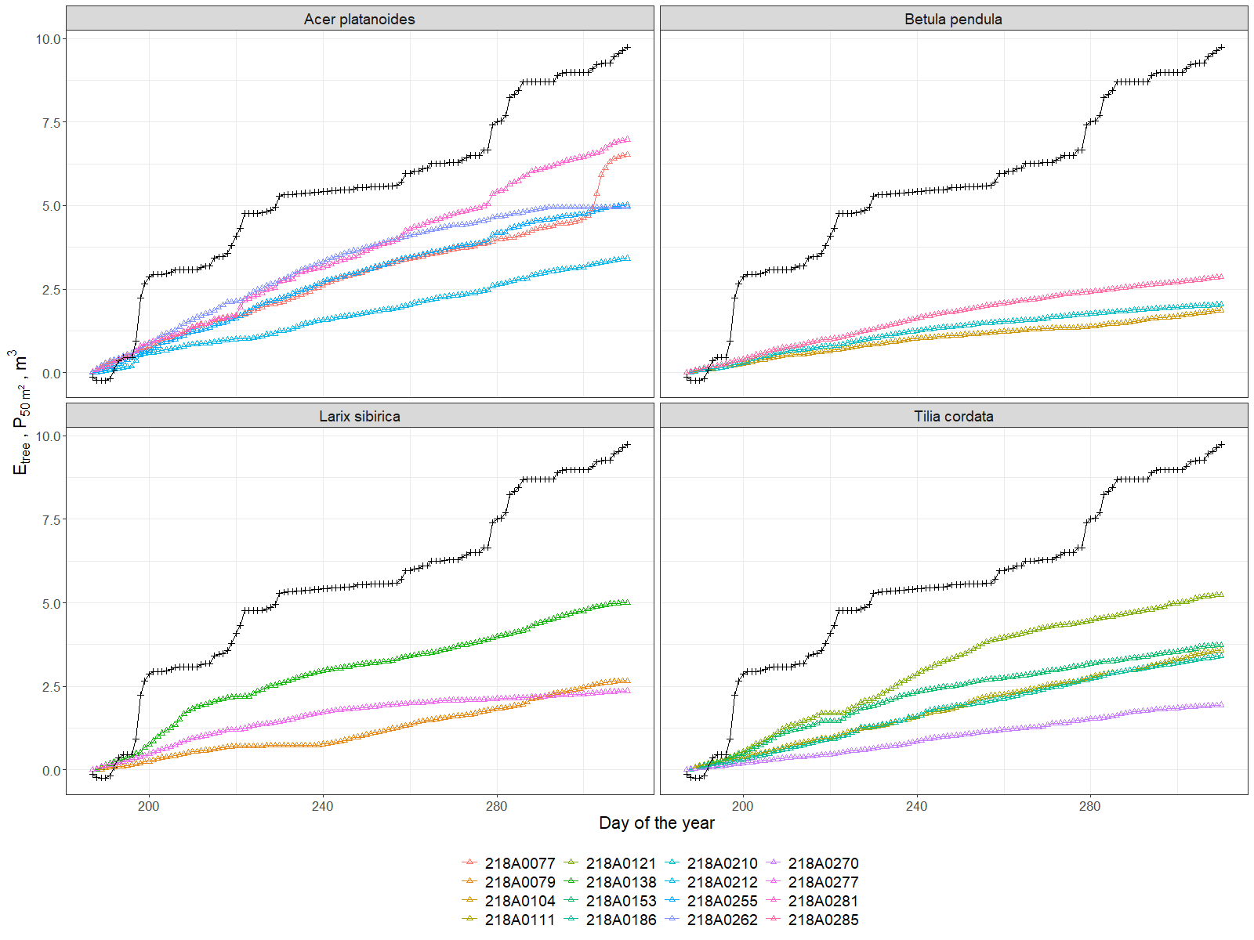

Figure4. Evapotranspiration of each tree compared to precipitated volume for 50 m2.

* 1. Energy consumption

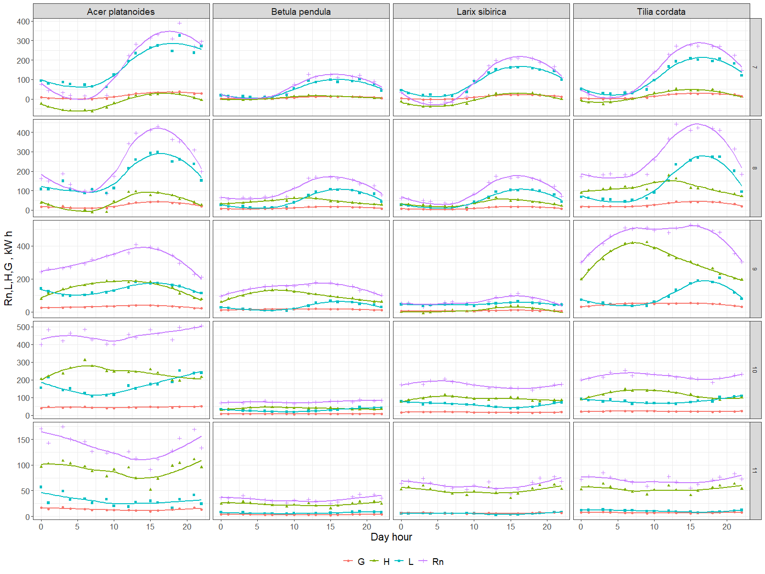

Figure 5. Average diurnal dynamics of Net energy absorption(Rn), sensible heat(H). latent heat(L) and soil heat (G) for different species averaged per month

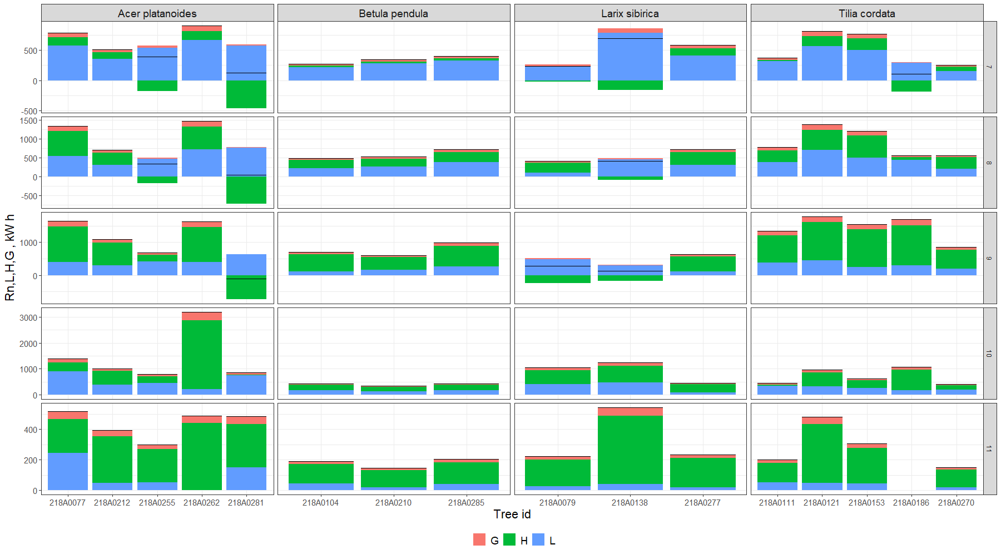

Figure 6. Energy removed from atmosphere monthly by each investigated tree - Net (Rn), due to sensible heat(H). latent heat(L) and soil heat (G)

* 1. LAI as a proxy

Our results show that we can calculate summative canopy area index (PAI) that is just a sum from leaves and wood (bark) from the spectrometer data. Thus, due to the period with and without leaves we successfully obtained both indexes. These periods are clearly visible on a graph, and we can easily distinguish the time of defoliation which was in one week in first days of October (Figure7). And what is especially interesting that for an individual tree this process takes in reality one-two days. Only due to our perception of green areas as a whole we think this takes time. As a result PAI of all trees was around 4 with less variety of Betula (3.5-4.5) and similar for Acer an Tillia (3-5). And even for Larix it was the same (3.5-5) despite our expectations; it can be possibly explain again with the higher location of a canopy.

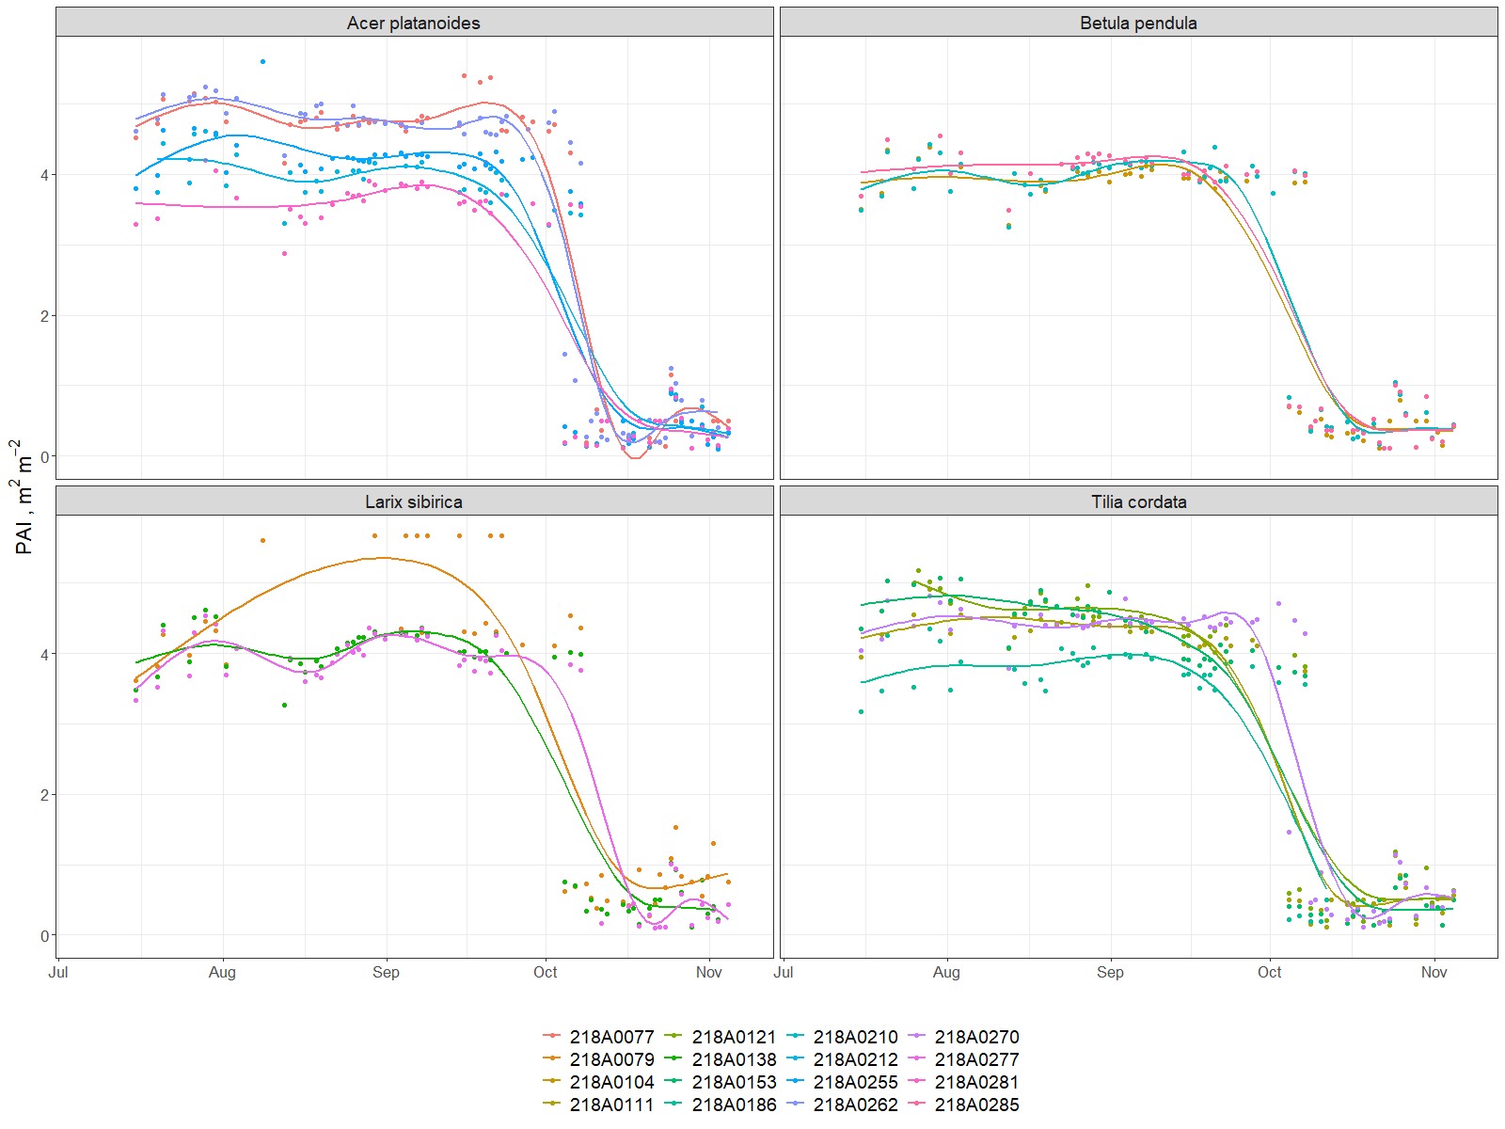

Figure7. PAI dynamics during investigated period (July-November, 2019)

* 1. Particulate adsorption

As particulate adsorption influenced by two main parameters – PAI and particulate concentration in air – dynamics of this parameter repeats the concentration dynamics. Thus we can see all the maximum pikes of pollutant emissions. The average lines for all trees look similar and adsorption was on level of two-three grams per day (annex 4). At least, resulting the whole season the average mass of particles adsorbed was around 300g for Acer, Larix and Tillia, and around 250g for Betula (Figure8). What is interesting, that during autumn we got the same levels (absolute numbers) of deposition while there are no leaves on the trees. It’s a bit strange and need to be rechecked and proofed especially.

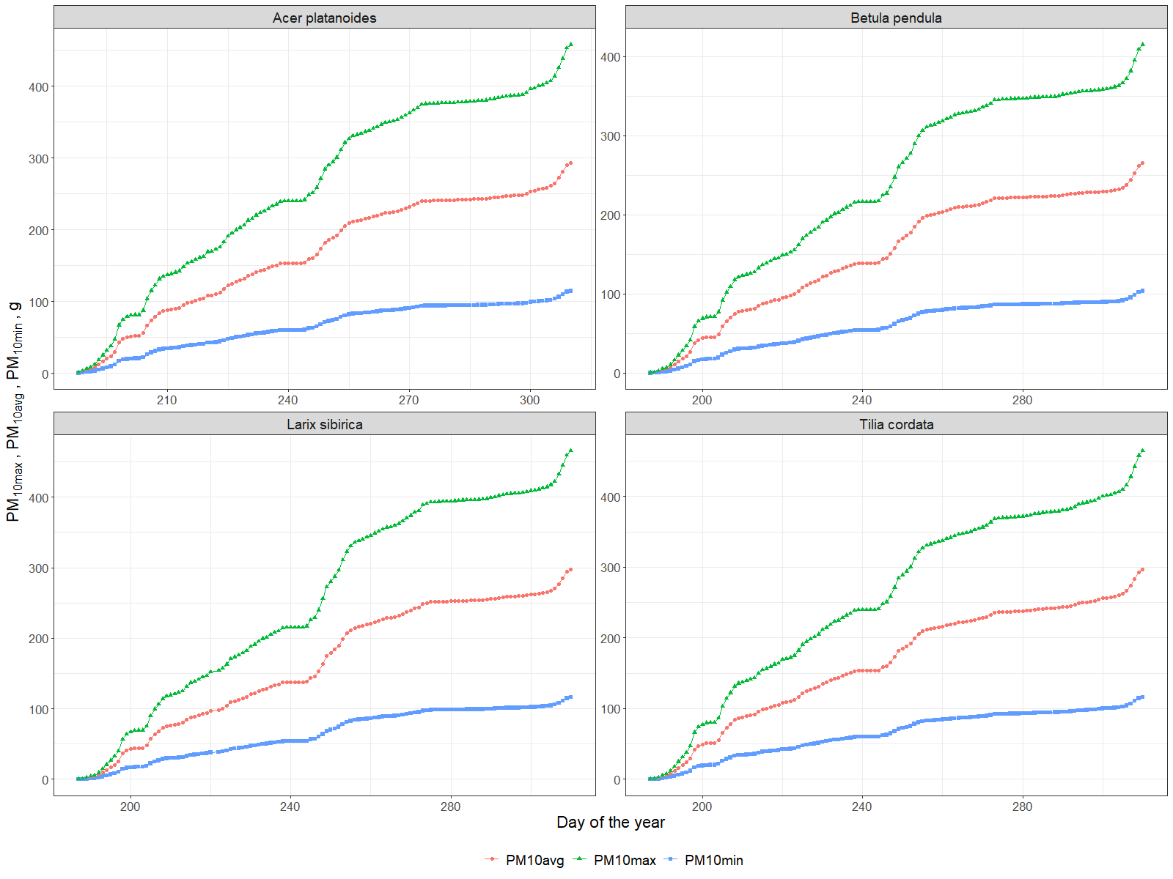

Figure8. Cumulative particulate adsorption (minimum, average and maximum) by tree leaves per investigated period (July-November, 2019).

* 1. Summative services and their influencing factors

According our findings there was 12.92 kg of Carbon stored, 3.67 m3 of water transpired, 4640.92 kWh spent for microclimate regulation and 273.93 g of PM10 adsorbed by average tree per investigated period (July-November, 2019). This results show that the average Moscow tree produces a lot of benefits even every hour but this values differ much (up to ten times) from one individual to another. For decision-making in urban planning context cumulative information may be more useful, so we summarize for each tree main ecosystem services indicators in a table 4.

Table 4. Summative of ecosystem services produced by each tree per investigated period (July-November, 2019)

|  |  |  |  |  |
| --- | --- | --- | --- | --- |
| **Tree ID** | **Carbon stored, kg** | **Transpiration, m3** | **Energy absorbed, kWh** | **Adsorbed PM10avg, g** |
| platanoides | | | | |
| 218A0077 | 17.46 | 6.22 | 8185.42 | 320.81 |
| 218A0212 | 11.85 | 3.22 | 5286.89 | 267.05 |
| 218A0255 | 16.85 | 4.59 | 3762.77 | 273.06 |
| 218A0262 | 11.25 | 4.81 | 6443.03 | 314.70 |
| 218A0281 | 20.62 | 6.76 | 2066.20 | 243.31 |
| Betula pendula | | | | |
| 218A0104 | 3.25 | 1.82 | 3025.22 | 250.40 |
| 218A0210 | 2.98 | 2.03 | 2804.55 | 267.52 |
| 218A0285 | 3.79 | 2.80 | 3923.20 | 270.45 |
| Larix sibirica | | | | |
| 218A0079 | 8.45 | 3.13 | 2633.33 | 305.54 |
| 218A0138 | 10.43 | 4.93 | 4491.73 | 264.36 |
| 218A0277 | 5.47 | 2.25 | 3738.55 | 242.04 |
| Tilia cordata | | | | |
| 218A0111 | 8.39 | 3.52 | 4275.98 | 275.23 |
| 218A0121 | 21.04 | 4.99 | 7670.72 | 276.89 |
| 218A0153 | 14.98 | 3.72 | 6254.02 | 299.00 |
| 218A0186 | 24.40 | 2.88 | 5302.65 | 227.22 |
| 218A0270 | 5.91 | 1.86 | 3185.46 | 298.15 |

Our analysis of influencing factors showed (annex 5) that diameter correlated with carbon stored (R2=0.81) and transpiration (R2=0.65) pretty well with clearly understandable reasons, while energy consumption showed low relation (R2=0.3). Services provided by different species, even if we reduce the diameter influence, also differ: more effective was Acer, than Tillia and Larix while the “looser” was Betula (possibly because it was younger than others).

**4. Discussion.**

4.1. General results

Our results show that Tree Talker devices can be used in principle for monitoring UGI ecosystem services in real time, and the obtained measurement values are largely consistent with earlier publications (Nowak and Crane 2002; Nowak et al. 2018). In addition we can calculate the value of a single tree services using existing prices for electricity, wastewater disposal, global carbon value and pm10 reduction. So, the cost for the tree differs from 50 to 600$ per investigated period with an average number of 250$ where 99% of this price created by the energy spent for local climate regulation.

Trees energy losses had high variation between species, individual trees and seasons. Authors posses that main variability between individual trees was due to difference in size of the canopy and position of the tree in the plot. Nevertheless, there are not so much publication about energy balance of boreal urban trees, we got comparable number for lime in summer months. (Moser et. al, 2015)

4.2. Discuss on factors influence and day-night or seasonal dynamics with possible comparison with other instrumental or RS –based measurements from literature to show differences.

Canopy cooling effect diurnal and seasonal dynamics was in accordance with literature (Rahman et al. 2019). It is rather rarely noticed that in boreal cities at night urban trees release heat accumulated during the day and air temperature under the canopies becomes higher. This effect is especially noticeable for trees with higher trunk to canopy biomass ratio (*Larix sibirica*) and during the period with higher differences between day and night temperatures(September))

For investigated period individual trees was able to transpirate all precipitated water volume around them in area from 20 (*Betula pendula*) to 70m2 (*Acer platanoides*), which positively correlates with size and density of those species canopies , Taking into account density of the stand it can be assumed that for investigated plot annual rainfall and transpiration could be close for years without extreme rainfall ranges, what was shown for boreal urban trees of other cities (Rahman et al. 2019 , Pirinen et al. 2012). Such information obtained real time could considerably contribute to cities stormwater management (Scharenbroch et al. 2016)

*4.3. Further technology development*

Several indicators were calculated with certain assumptions or indirectly via proxy that lead to some uncertainties. Leaf Area Index, calculated from the spectrometer data was a bit lower than expected maybe because the entire canopy in the visible area of the sensor was not captured or was affected by close position of the device to the trunk. Thus, it is necessary to compare with standard technics (e.g. camera with fish-eye lens) more precise on the one hand. On the other – spectrometer, unlike the camera, allows the calculation of NDVI-type spectral indexes, which is also important for UGI monitoring to provide information about tree health. However, equipping the device with additional sensors may allow us to do measurements instrumentally in direct way. In particular, the installation of an anemometer will provide exact data on wind speed reduction, and sensors for particle matters and gases concentration in the air will boost our knowledge in the process of pollutants adsorption by the tree leaves in situ. It is also possible to use the microphones to assess the quality of the soundscape and the noise pollution reduction by the green infrastructure (Mydlarz et al. 2019; Doser et al. 2020) and to evaluate associated biodiversity with the help of recorded bird songs (Farina et al. 2014; Margaritis et al. 2018). Nevertheless, the technical development of sensors along with people engagement to citizen science will be inevitable (Schröter et al. 2017; Nitoslawski et al. 2019), thus it will be important to adapt them to the task of monitoring those parameters that are important for urban planning decisions (Cortinovis and Geneletti 2019).

*4.4. Indicators and their informativity for further assessment and use in urban green infrastructure monitoring and planning.*

Among the indicators presented in the article, perhaps not all of them can be used for practical purposes directly. Air temperature and humidity under the canopy of city trees can be presented as is for people, as well as wind speed for example. However, in order to monitor the quality of the urban environment associated with green infrastructure, it is probably worth developing special scales of air quality, microclimate comfort and noise pollution levels – in this form it makes more clear information for citizens. On the other hand, for spatial planning tasks, annual or seasonal indicators of ecosystem services provided by one or another tree species at its specific age, height and condition will be more useful in the form of empirical data tables and spatial models, as it will affect which and where to plant trees (Bodnaruk et al. 2017). In addition, it is also necessary to take into account disservices associated with urban trees such as the fall of weakened and diseased trees on cars, infrastructure and buildings, and the allergic reaction of people to tree pollen (Speak et al. 2018; Teixeira et al. 2019). These parameters should also be continuously monitored and reported in real time for rapid response or timely prevention.

**5. Conclusion**

**6. Literature**

1. Aalders I, Stanik N (2019) Spatial units and scales for cultural ecosystem services: a comparison illustrated by cultural heritage and entertainment services in Scotland. Landscape Ecology 34:1635–1651. https://doi.org/10.1007/s10980-019-00827-6
2. Albino V, Berardi U, Dangelico RM (2015) Smart Cities: Definitions, Dimensions, Performance, and Initiatives. Journal of Urban Technology 22:3–21. https://doi.org/10.1080/10630732.2014.942092
3. Alonzo M, Bookhagen B, Roberts DA (2014) Urban tree species mapping using hyperspectral and lidar data fusion. Remote Sensing of Environment 148:70–83. https://doi.org/10.1016/j.rse.2014.03.018
4. Andersson E, Barthel S, Borgström S, et al (2014) Reconnecting Cities to the Biosphere: Stewardship of Green Infrastructure and Urban Ecosystem Services. AMBIO 43:445–453. https://doi.org/10.1007/s13280-014-0506-y
5. Andrea F, Bini C, Amaducci S (2018) Soil and ecosystem services: Current knowledge and evidences from Italian case studies. Applied Soil Ecology 123:693–698. https://doi.org/10.1016/j.apsoil.2017.06.031
6. Bettencourt LMA, Lobo J, Helbing D, et al (2007) Growth, innovation, scaling, and the pace of life in cities. Proceedings of the National Academy of Sciences 104:7301–7306. https://doi.org/10.1073/pnas.0610172104
7. Blanusa T, Garratt M, Cathcart-James M, et al (2019) Urban hedges: A review of plant species and cultivars for ecosystem service delivery in north-west Europe. Urban Forestry & Urban Greening 44:126391. https://doi.org/10.1016/j.ufug.2019.126391
8. Bodnaruk EW, Kroll CN, Yang Y, et al (2017) Where to plant urban trees? A spatially explicit methodology to explore ecosystem service tradeoffs. Landscape and Urban Planning 157:457–467. https://doi.org/10.1016/j.landurbplan.2016.08.016
9. Bolund P, Hunhammar S (1999) Ecosystem services in urban areas. Ecological Economics 29:293–301. https://doi.org/10.1016/S0921-8009(99)00013-0
10. Burkhard B, Maes J, Potschin-Young M, et al (2018) Mapping and assessing ecosystem services in the EU - Lessons learned from the ESMERALDA approach of integration. One Ecosystem 3:. https://doi.org/10.3897/oneeco.3.e29153
11. Czúcz B, Arany I, Potschin-Young M, et al (2018) Where concepts meet the real world: A systematic review of ecosystem service indicators and their classification using CICES. Ecosystem Services 29:145–157. https://doi.org/10.1016/j.ecoser.2017.11.018
12. Drobnik T, Greiner L, Keller A, Grêt-Regamey A (2018) Soil quality indicators – From soil functions to ecosystem services. Ecological Indicators 94:151–169. https://doi.org/10.1016/j.ecolind.2018.06.052
13. Dye C (2008) Health and Urban Living. Science 319:766. https://doi.org/10.1126/science.1150198
14. Elliott S (2016) The potential for automating assisted natural regeneration of tropical forest ecosystems. Biotropica 48:825–833. https://doi.org/10.1111/btp.12387
15. Farina A, James P, Bobryk C, et al (2014) Low cost (audio) recording (LCR) for advancing soundscape ecology towards the conservation of sonic complexity and biodiversity in natural and urban landscapes. Urban Ecosystems 17:923–944. https://doi.org/10.1007/s11252-014-0365-0
16. Frumkin H (2003) Healthy Places: Exploring the Evidence. Am J Public Health 93:1451–1456. https://doi.org/10.2105/AJPH.93.9.1451
17. Gómez-Baggethun E, Barton DN (2013) Classifying and valuing ecosystem services for urban planning. Ecological Economics 86:235–245. https://doi.org/10.1016/j.ecolecon.2012.08.019
18. Grimm NB, Faeth SH, Golubiewski NE, et al (2008) Global Change and the Ecology of Cities. Science 319:756. https://doi.org/10.1126/science.1150195
19. Guo Z, Zhang L, Li Y (2010) Increased Dependence of Humans on Ecosystem Services and Biodiversity. PLoS ONE 5:e13113. https://doi.org/10.1371/journal.pone.0013113
20. Haaren C von, Lovett AA, Albert C (2019) Landscape planning with ecosystem services: theories and methods for application in Europe
21. Haase D, Larondelle N, Andersson E, et al (2014) A Quantitative Review of Urban Ecosystem Service Assessments: Concepts, Models, and Implementation. AMBIO 43:413–433. <https://doi.org/10.1007/s13280-014-0504-0>
22. Hirabayashi, S., Kroll, C.N., Nowak, D.J., 2011b. I-tree Eco Dry Deposition Model Descriptions. http://www.itreetools.org/eco/resources/iTree_Eco_Dry_Deposition_
23. Model_Descriptions_V1_1.pdf (accessed 15.02.12.)
24. Kitchin R (2014) The real-time city? Big data and smart urbanism. GeoJournal 79:1–14. https://doi.org/10.1007/s10708-013-9516-8
25. Krausmann F, Lauk C, Haas W, Wiedenhofer D (2018) From resource extraction to outflows of wastes and emissions: The socioeconomic metabolism of the global economy, 1900–2015. Global Environmental Change 52:131–140. https://doi.org/10.1016/j.gloenvcha.2018.07.003
26. Kremer P, Hamstead ZA, McPhearson T (2016) The value of urban ecosystem services in New York City: A spatially explicit multicriteria analysis of landscape scale valuation scenarios. Environmental Science & Policy 62:57–68. https://doi.org/10.1016/j.envsci.2016.04.012
27. La Rosa D, Spyra M, Inostroza L (2016) Indicators of Cultural Ecosystem Services for urban planning: A review. Ecological Indicators 61:74–89. https://doi.org/10.1016/j.ecolind.2015.04.028
28. Lederbogen F, Kirsch P, Haddad L, et al (2011) City living and urban upbringing affect neural social stress processing in humans. Nature 474:498–501. https://doi.org/10.1038/nature10190
29. Lilly PJ, Jenkins JC, Carroll MJ (2015) Management alters C allocation in turfgrass lawns. Landscape and Urban Planning 134:119–126. https://doi.org/10.1016/j.landurbplan.2014.10.011
30. Lin J, Kroll CN, Nowak DJ, Greenfield EJ (2019) A review of urban forest modeling: Implications for management and future research. Urban Forestry & Urban Greening 43:126366. https://doi.org/10.1016/j.ufug.2019.126366
31. Lovell ST, Taylor JR (2013) Supplying urban ecosystem services through multifunctional green infrastructure in the United States. Landscape Ecology 28:1447–1463. https://doi.org/10.1007/s10980-013-9912-y
32. Lovett MG (1994) Atmospheric deposition of nutrients and pollutants in North America: an ecological perspective. Ecological Applications,4(4),1994, pp. 629-650.
33. Luederitz C, Brink E, Gralla F, et al (2015) A review of urban ecosystem services: six key challenges for future research. Ecosystem Services 14:98–112. https://doi.org/10.1016/j.ecoser.2015.05.001
34. Mascarenhas A, Ramos TB, Haase D, Santos R (2016) Participatory selection of ecosystem services for spatial planning: Insights from the Lisbon Metropolitan Area, Portugal. Ecosystem Services 18:87–99. https://doi.org/10.1016/j.ecoser.2016.02.011
35. Mesas-Carrascosa FJ, Verdú Santano D, Meroño JE, et al (2015) Open source hardware to monitor environmental parameters in precision agriculture. Biosystems Engineering 137:73–83. https://doi.org/10.1016/j.biosystemseng.2015.07.005
36. Mexia T, Vieira J, Príncipe A, et al (2018) Ecosystem services: Urban parks under a magnifying glass. Environmental Research 160:469–478. <https://doi.org/10.1016/j.envres.2017.10.023>
37. Monsi M, Saeki T. (1953). U¨ber den Lichtfaktor in den Pflanzengesellschaften und seine Bedeutung fu¨r die Stoffproduktion. Jpn J Bot. 14:22–52. [Republished in English: Monsi M, Saeki T. 2005. On the factor light in plant communities and its importance for matter production. Ann Bot. 95:549–567.]
38. Moser, A., Rötzer, T., Pauleit, S., & Pretzsch, H. (2015). Structure and ecosystem services of small-leaved lime (Tilia cordata Mill.) and black locust (Robinia pseudoacacia L.) in urban environments. *Urban Forestry and Urban Greening*, *14*(4), 1110–1121. https://doi.org/10.1016/j.ufug.2015.10.005
39. Müller F, Burkhard B (2012) The indicator side of ecosystem services. Ecosystem Services 1:26–30. https://doi.org/10.1016/j.ecoser.2012.06.001
40. Mydlarz C, Sharma M, Lockerman Y, et al (2019) The Life of a New York City Noise Sensor Network. Sensors 19:1415. https://doi.org/10.3390/s19061415
41. Nitoslawski SA, Galle NJ, Van Den Bosch CK, Steenberg JWN (2019) Smarter ecosystems for smarter cities? A review of trends, technologies, and turning points for smart urban forestry. Sustainable Cities and Society 51:101770. https://doi.org/10.1016/j.scs.2019.101770
42. Njue N, Stenfert Kroese J, Gräf J, et al (2019) Citizen science in hydrological monitoring and ecosystem services management: State of the art and future prospects. Science of The Total Environment 693:133531. https://doi.org/10.1016/j.scitotenv.2019.07.337
43. Norton L, Greene S, Scholefield P, Dunbar M (2016) The importance of scale in the development of ecosystem service indicators? Ecological Indicators 61:130–140. https://doi.org/10.1016/j.ecolind.2015.08.051
44. Nowak DJ, Crane DE (2002) Carbon storage and sequestration by urban trees in the USA. Environmental Pollution 116:381–389. https://doi.org/10.1016/S0269-7491(01)00214-7
45. Nowak DJ, Crane DE, Stevens JC (2006) Air pollution removal by urban trees and shrubs in the United States. Urban Forestry & Urban Greening 4:115–123. https://doi.org/10.1016/j.ufug.2006.01.007
46. Nowak DJ, Hirabayashi S, Doyle M, et al (2018) Air pollution removal by urban forests in Canada and its effect on air quality and human health. Urban Forestry & Urban Greening 29:40–48. https://doi.org/10.1016/j.ufug.2017.10.019
47. Opdam P, Albert C, Fürst C, et al (2015) Ecosystem services for connecting actors – lessons from a symposium. Change and Adaptation in Socio-Ecological Systems 2:. <https://doi.org/10.1515/cass-2015-0001>
48. R Core Team (2020). R: A language and environment for statistical computing. R Foundation for Statistical Computing, Vienna, Austria. URL <https://www.R-project.org/>
49. Rahman, M.A., Moser, A., Rötzer, T. et al. Comparing the transpirational and shading effects of two contrasting urban tree species. Urban Ecosyst 22, 683–697 (2019).
50. Rötzer T, Rahman MA, Moser-Reischl A, et al (2019) Process based simulation of tree growth and ecosystem services of urban trees under present and future climate conditions. Science of The Total Environment 676:651–664. <https://doi.org/10.1016/j.scitotenv.2019.04.235>
51. Scharenbroch BC, Morgenroth J, Maule B (2016) Tree species suitability to bioswales and impact on the urban water budget. J Environ Qual 45:199–206
52. Schröter M, Kraemer R, Mantel M, et al (2017) Citizen science for assessing ecosystem services: Status, challenges and opportunities. Ecosystem Services 28:80–94. https://doi.org/10.1016/j.ecoser.2017.09.017
53. Schwilch G, Lemann T, Berglund Ö, et al (2018) Assessing Impacts of Soil Management Measures on Ecosystem Services. Sustainability 10:4416. https://doi.org/10.3390/su10124416
54. Seto KC, Guneralp B, Hutyra LR (2012) Global forecasts of urban expansion to 2030 and direct impacts on biodiversity and carbon pools. Proceedings of the National Academy of Sciences 109:16083–16088. https://doi.org/10.1073/pnas.1211658109
55. Song XP, Tan PY, Edwards P, Richards D (2018) The economic benefits and costs of trees in urban forest stewardship: A systematic review. Urban Forestry & Urban Greening 29:162–170. https://doi.org/10.1016/j.ufug.2017.11.017
56. Speak A, Escobedo FJ, Russo A, Zerbe S (2018) An ecosystem service-disservice ratio: Using composite indicators to assess the net benefits of urban trees. Ecological Indicators 95:544–553. https://doi.org/10.1016/j.ecolind.2018.07.048
57. Spyra M, Kleemann J, Cetin NI, et al (2019) The ecosystem services concept: a new Esperanto to facilitate participatory planning processes? Landscape Ecology 34:1715–1735. https://doi.org/10.1007/s10980-018-0745-6
58. Teixeira FZ, Bachi L, Blanco J, et al (2019) Perceived ecosystem services (ES) and ecosystem disservices (EDS) from trees: insights from three case studies in Brazil and France. Landscape Ecology 34:1583–1600. https://doi.org/10.1007/s10980-019-00778-y
59. UNEP (ed) (2010) Mainstreaming the economics of nature: a synthesis of the approach, conclusions and recommendations of teeb. UNEP, Geneva
60. van Oudenhoven APE, Petz K, Alkemade R, et al (2012) Framework for systematic indicator selection to assess effects of land management on ecosystem services. Ecological Indicators 21:110–122. https://doi.org/10.1016/j.ecolind.2012.01.012
61. van Oudenhoven APE, Schröter M, Drakou EG, et al (2018) Key criteria for developing ecosystem service indicators to inform decision making. Ecological Indicators 95:417–426. https://doi.org/10.1016/j.ecolind.2018.06.020
62. Van Reeth W (2013) Ecosystem Service Indicators. In: Ecosystem Services. Elsevier, pp 41–61
63. Vihervaara P, Viinikka A, Brander L, et al (2019) Methodological interlinkages for mapping ecosystem services – from data to analysis and decision-support. One Ecosystem 4:. https://doi.org/10.3897/oneeco.4.e26368
64. von Döhren P, Haase D (2019) Risk assessment concerning urban ecosystem disservices: The example of street trees in Berlin, Germany. Ecosystem Services 40:101031. https://doi.org/10.1016/j.ecoser.2019.101031
65. Wilkinson C, Saarne T, Peterson GD, Colding J (2013) Strategic Spatial Planning and the Ecosystem Services Concept - an Historical Exploration. E&S 18:art37. https://doi.org/10.5751/ES-05368-180137
66. Willcock S, Hooftman D, Sitas N, et al (2016) Do ecosystem service maps and models meet stakeholders’ needs? A preliminary survey across sub-Saharan Africa. Ecosystem Services 18:110–117. https://doi.org/10.1016/j.ecoser.2016.02.038
67. Wissen Hayek U, Teich M, Klein TM, Grêt-Regamey A (2016) Bringing ecosystem services indicators into spatial planning practice: Lessons from collaborative development of a web-based visualization platform. Ecological Indicators 61:90–99. https://doi.org/10.1016/j.ecolind.2015.03.035
68. Wu J (2013) Landscape sustainability science: ecosystem services and human well-being in changing landscapes. Landscape Ecol 28:999–1023. https://doi.org/10.1007/s10980-013-9894-9
69. Zhao C, Sander HA (2018) Assessing the sensitivity of urban ecosystem service maps to input spatial data resolution and method choice. Landscape and Urban Planning 175:11–22. https://doi.org/10.1016/j.landurbplan.2018.03.007

Annex 1. Daily and diurnal by month dynamics of the air temperature under and outside of the canopy

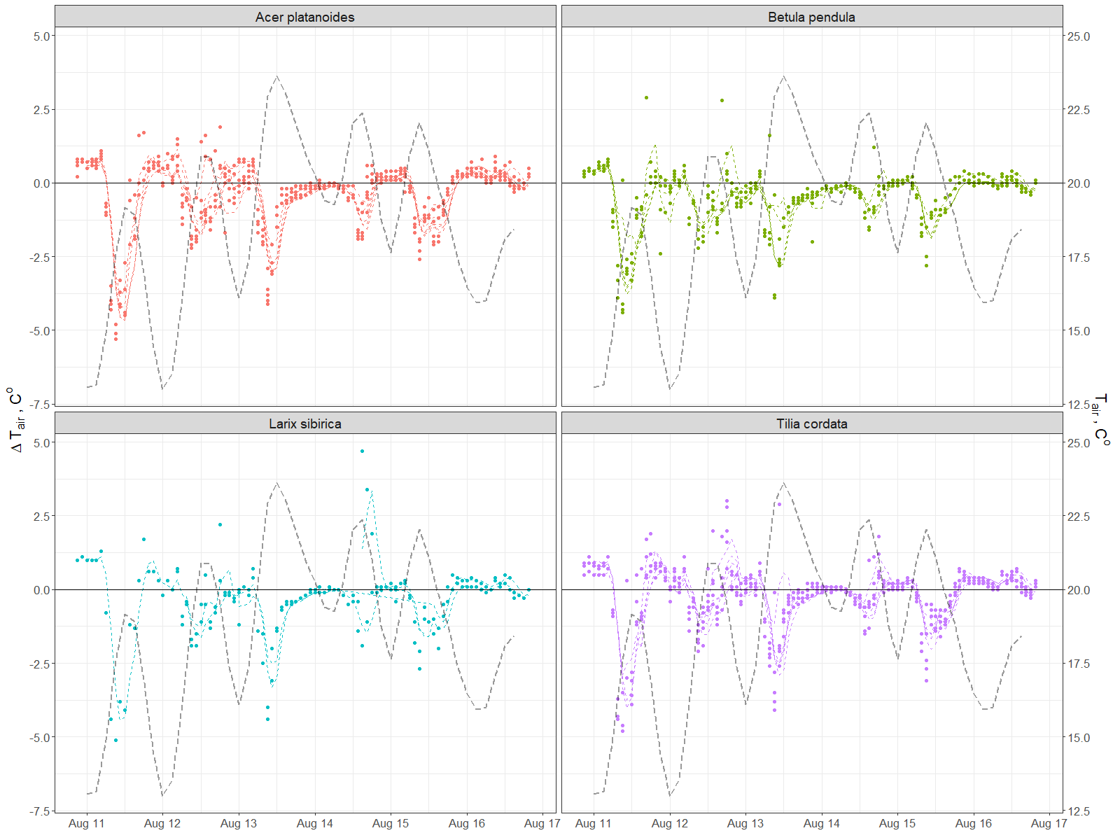

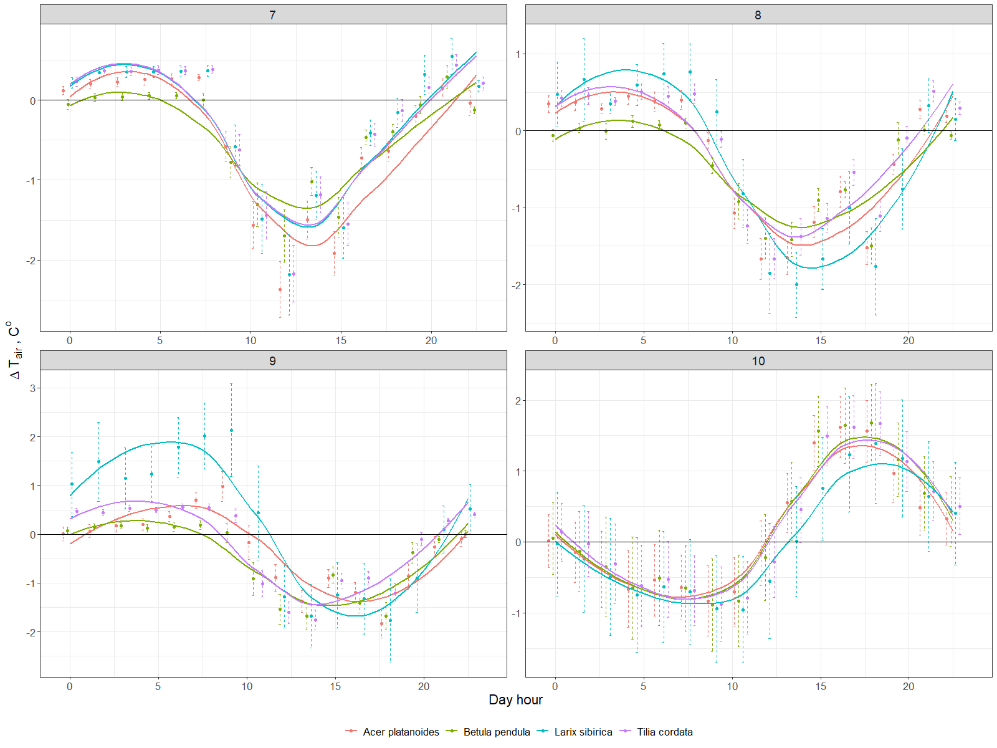

Annex 2. Daily and diurnal by month dynamics of the air relative humidity under and outside of the canopy

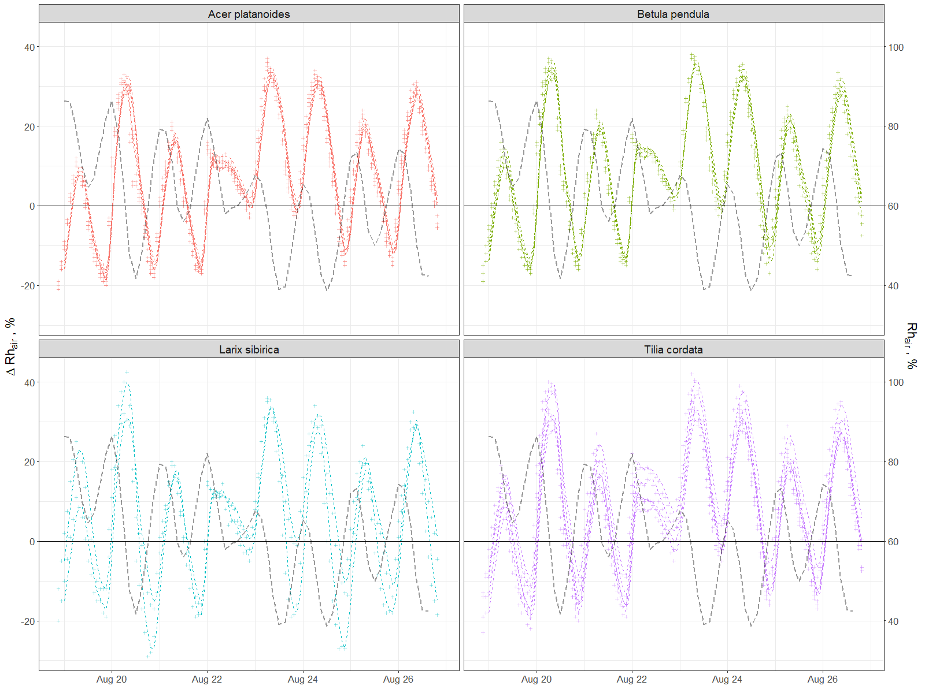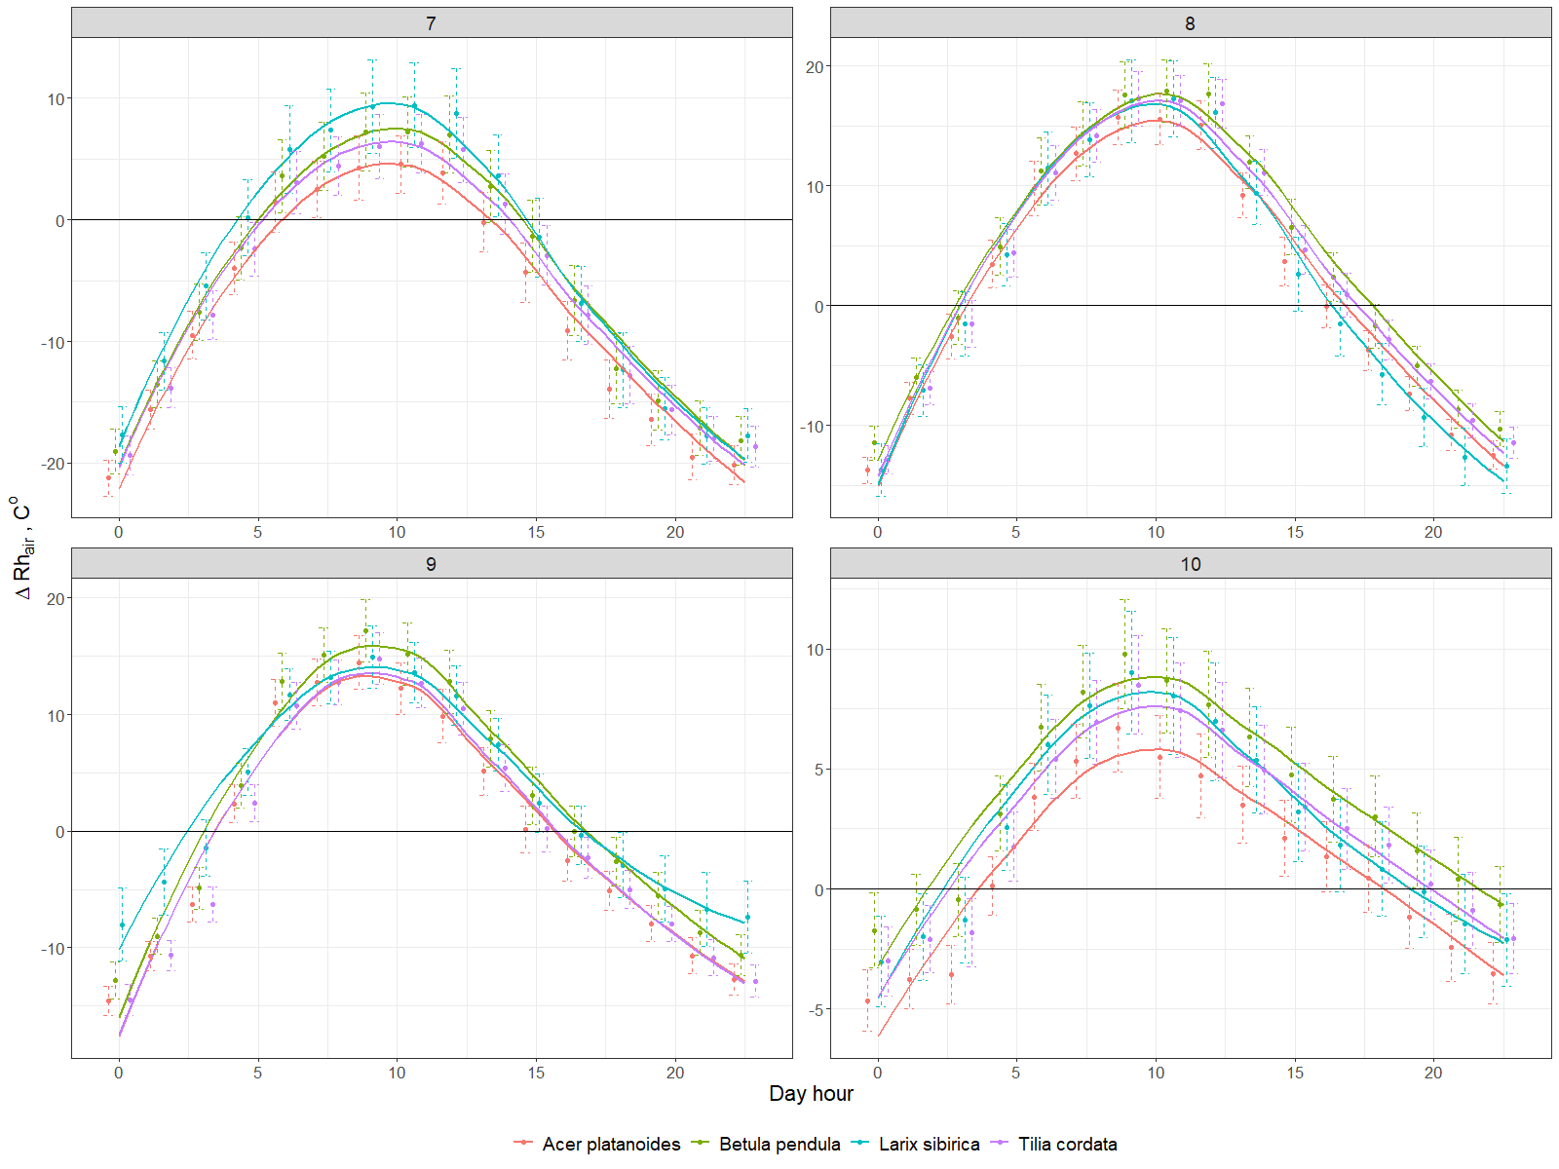

Annex 3. Leaf and wood area indexes for each tree during investigated period

|  |  |  |  |  |  |  |  |  |  |  |  |  |  |  |  |  |
| --- | --- | --- | --- | --- | --- | --- | --- | --- | --- | --- | --- | --- | --- | --- | --- | --- |
|  | Acer platanoides | | | | | | Betula pendula | | | | Larix sibirica | | | Tilia cordata | | |
| **Tree ID** | 218A0077 | 218A0212 | 218A0255 | 218A0262 | 218A0281 | 218A0104 | 218A0210 | 218A0285 | 218A0079 | 218A0138 | 218A0277 | 218A0111 | 218A0121 | 218A0153 | 218A0186 | 218A0270 |
| **PAI, m2m-2** | 4.16 | 3.27 | 3.44 | 3.97 | 2.90 | 3.06 | 3.28 | 3.22 | 3.55 | 3.35 | 3.68 | 3.42 | 3.73 | 3.63 | 3.32 | 3.66 |
| **WAI, m2m-2** | 0.58 | 0.63 | 0.52 | 0.57 | 0.53 | 0.54 | 0.53 | 0.52 | 0.80 | 0.56 | 0.47 | 0.63 | 0.67 | 0.53 | 0.52 | 0.58 |
| **LAI, m2m-2** | 3.59 | 2.64 | 2.91 | 3.40 | 2.37 | 2.52 | 2.75 | 2.69 | 2.74 | 2.79 | 3.21 | 2.79 | 3.06 | 3.10 | 2.80 | 3.08 |

Annex 4. Particulate adsorption (minimum, average and maximum) by tree leaves day by day.

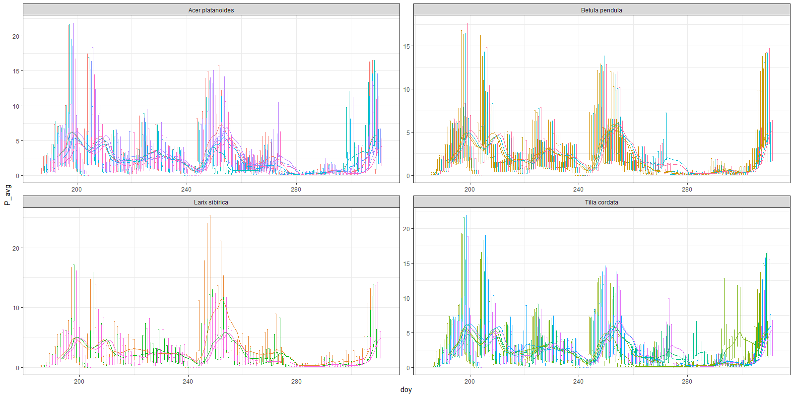

Annex 5. Corellogram of ESI and trees characteristics.

